Healthy Eating Policy

Healthy Eating Policy

It is the policy of St. Mary’s National School that healthy eating be encouraged by pursuing both education for pupils and guidance for parents. We approach this policy with the understanding that ultimately children’s appetites and tastes differ and it is a parent’s / guardian’s responsibility to ensure that his / her child eats healthily at all times, including during school activities.

In the course of studying sciences children will be exploring
- Food groups
- The consequences of a poor diet
- The food pyramid

All children are encouraged to eat balanced and proportionate meals at all times including those meals eaten while in school.
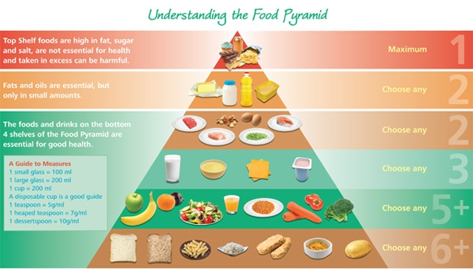

The food pyramid outlines an excellent common sense approach to healthy and balanced eating. All children’s lunches should contain a majority of items from the four lower food groups.
Food selected from each level should be in decreasing amounts.

In St. Mary’s No.2 National School two lunch breaks are timetabled.
Sos beag 11:05am – 11:15am
Am lóin 12:30pm – 1.00pm

The following is a list of suggested foods for a healthy, balanced school lunch.

Group 1  Bread/ cereal / pasta  Carbohydrate | Sandwiches / Rolls  Pitta Bread Pockets  Homemade Baked Items  Nan Bread  Pasta Salad  Crackers  Crisp Bread
Group 2  Fruit / Vegetables | Any fruit or vegetable items  Salad in a box  Please remember to peel or cut fruit for younger students
Group 3  Dairy | Cheese strings  Small packets cheese (e.g.5 in a bag size)  Yoghurts (pots or frubes) with spoon  Milk to drink
Group 4  Meat  Protein | Meat in sandwiches or salad  Cold meats or tuna  Eggs..etc
Drinks | Milk / Fruit Juice / Water

We ask that children do not bring the following to school:

Snacks known to be high in sugar, saturated fat, salt, additives and preservatives, including the following:

- Crisps ( including crisp-style snacks)
- Fizzy drinks ( including fizzy fruit–flavoured water, juices, etc)
- Sweets
- Chocolate biscuits/bars
- Cereal bars
- Chewing gum
- Fruit winders
- Flavoured Popcorn

Green Flag School

With this in mind, children are also asked to:
- Take home ( in lunchbox) all uneaten food, silver paper, wrappings, container and cartons
- Put only fruit peel into the compost bins
- Not bring in cans and glass – for safety reasons.

N.B. Parents / Guardians of any child with a medical condition which requires a special diet should contact the school.

This policy was ratified by the Board of Management on______________________________.
It will be reviewed on _______________.

Signed:__________________________________ Date:_________________________

