School MINI- FAIR
A very big thank you to all who supported our School Fair before the Easter vacation. We are delighted to say that €1020 was raised in total. We hope that you all enjoyed it just as much as the boys and girls. Monies raised will certainly be put to good use to purchase resources for the classrooms.
Villiers Sports’ Day
5th and 6th class pupils have been invited to attend Villiers Sports’ Day on Wednesday 26th April. A detailed letter will be distributed to parents of 5th and 6th class in due course.
Confirmation
We would like to take this opportunity to wish some of our sixth class pupils the very best as they receive their Confirmation in the forthcoming weeks. We congratulate the following pupils on receiving their Confirmation:
Maciek Borzecki
Amanda Bednarz
Alexander Dowling-Hussey
Sofiya Percy
Mateusz Piecyk
Scott Powell
Wiktoria Soszynska
Maja Szalanska
Ethan Walsh

Board of Management
The next meeting of our Board of Management will take place on Tuesday 18th April.
School Books’ Grant for September 2023
Please find attached to this email a letter explaining how the School Books Grant will be administered for the forthcoming school year.
Arts Programme
We are delighted that pupils from 1st to 6th classes will participate in an Art’s Programme, where a visiting artist will come into the school and work with the children,. This will take place weekly for a period of 4 weeks. We hope that the children enjoy the experience.
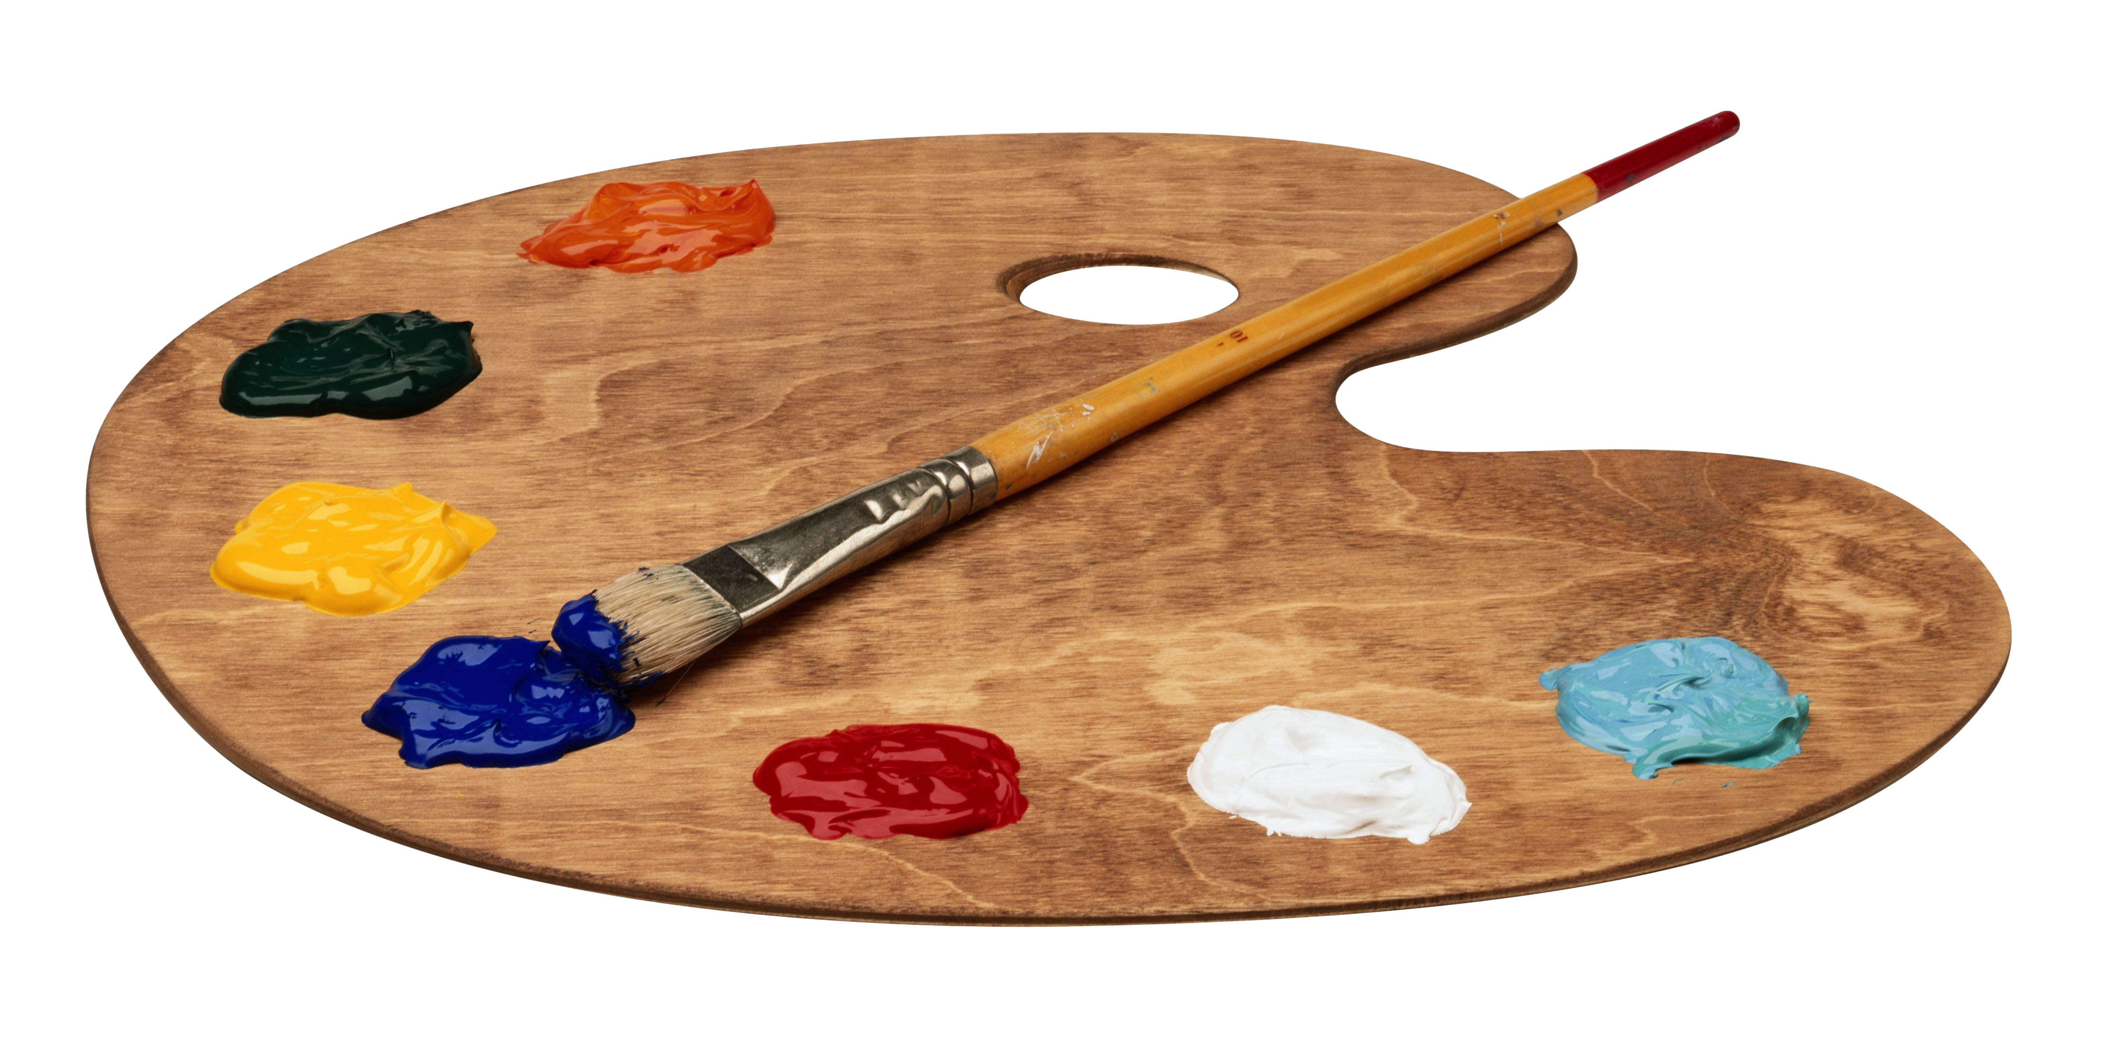
Dates for your diary
Staff meeting
Reminder: There will be an early closure at 12.30pm Friday 28th April to facilitate a staff meeting. The school bus will collect early on this day.
School closure
Please note that the school will be closed for staff training on Friday 2nd June. This is an additional closure to those already scheduled.
School Testing
School Testing for Senior Infants to 6th classes will take place during the week beginning 15th May. If at all possible, we would ask that pupils are not absent during this week.
Swimming
Swimming will commence on Wednesday 28th April and will continue on 3rd, 10th and 17th and 24th May for all classes. The swimming lesson will take place from 12.00pm to 12.50pm.
If any infant parents are able to be at the pool at 11.40am and /or 12.50pm to help your child change, it would be very much appreciated. We greatly appreciate that this is very difficult for those who are working but as I am sure you will agree this is a fantastic opportunity for the boys and girls. A very big thank you to parents of infant children who come to the pool to help out.
All pupils must bring swimsuits and swimming hats on these days. Good behaviour is expected of all pupils at the swimming pool

GAA lessons
GAA lessons will continue each Thursday for the Term 3.
Sponsored Walk
On Friday 19th May, all pupils will participate in a Sponsored Walk around the town of Nenagh. Sponsorship cards will be distributed to all pupils shortly. All monies raised will be put towards the cost of buses for the upcoming School Tours.
School Tours
It hard to believe that we have reached the time when we are talking about School Tours.
Junior Infants, Senior Infants and 1st classes will go on their school tour on Thursday 8th June and 2nd to 6th classes will go on their school tour on Thursday 1st June.

A more detailed letter with details of the tour, consent form and payment request will be sent to all parents in the next few weeks.

School Sport’s Day
Our School Sport’s Day has been provisionally set for Friday 16th June.
(weather permitting) More details will follow.

6th class Graduation
6th class Graduation will take place on Wednesday 21st June at 12.30pm. More details to follow.

